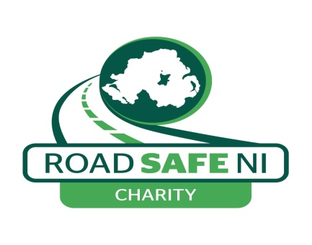Privacy Policy
How we respect privacy when we deal with personal information collected by our organisation

Road Safe NI may collect personal details of volunteers, life members and participants that engage in our road safety programmes or projects including email addresses, telephone numbers or other information. This is to ensure we can contact interested parties to keep them informed of campaigns, projects or road safety courses they are interested or participating in.

Road Safe NI will only store your personal information for a limited period of time eg until the road safety project or campaign you are involved in is completed. Your information will then be securely deleted or destroyed and we will then only extract demographic information to inform research.

Road Safe NI recognises your right to access your personal data at any time. We have processes in place to ensure that your data is regularly reviewed. We will securely dispose of your data when it is no longer required or if you request us to erase it.

This Privacy Policy applies to information we (Road Safe NI) collect about individuals who interact with our organisation. It explains what personal information we collect and how we use it.
If you have any comments or questions about this notice, feel free to contact us at info@roadsafeni.com

1. Personal data that we process
The following table explains the types of data we collect and the legal basis, under current data protection legislation, on which this data is processed.
Purpose | Data (key elements) | Basis
Enquiring about our organisation and our road safety work | Name, email, message | Legitimate interests - it is necessary for us to read and store your message so that we can respond in the way that you would expect.
Subscribing to email updates about our work | Name, email | Consent - you have given your active consent.
Making a donation | Name, email, address, payment information | Legitimate interests - this information is necessary for us to fulfill your intention of donating money and your expectation of receiving a confirmation message.
Signing up as a committee member / life member or volunteer | Name, address, email, telephone number | Contract - by signing up as a life member /committee member or volunteer, you have entered into a voluntary contractual relationship with Road Safe NI as set out in our Governing Document and Charity Legislation.
Signing up to a road safety course or project as a participant | Demographic Information eg Name, DOB, Postcode. | Consent - you have given your active consent.

2. How we use your data
We will only use your data in a manner that is appropriate considering the basis on which that data was collected, as set out in the table at the top of this policy.
For example, we may use your personal information to:
- reply to enquiries you send to us;
- Contact you with information about a road safety project you have enquired about;
- handle donations or other transactions that you initiate;
- where you have specifically agreed to this, send you marketing communications by email relating to our work which we think may be of interest to you.

3. When we share your data
We will only pass your data to third parties in the following circumstances:
- you have provided your explicit consent for us to pass data to a named third party; or
- we are required by law to share your data.

4. How long we keep your data
We take the principles of data minimisation and removal seriously and have internal policies in place to ensure that we only ever ask for the minimum amount of data for the associated purpose and delete that data promptly once it is no longer required.
Where data is collected on the basis of consent, we will seek renewal of consent at least every three years.

5. Rights you have over your data
You have a range of rights over your data, which include the following:
- Where data processing is based on consent, you may revoke this consent at any time and we will make it as easy as possible for you to do this (for example by putting ‘unsubscribe’ links at the bottom of all our marketing emails).
- You have the right to ask for rectification and/or deletion of your information.
- You have the right of access to your information.
- You have the right to lodge a complaint with the Information Commissioner if you feel your rights have been infringed.
A full summary of your legal rights over your data can be found on the Information Commissioner’s website here: https://ico.org.uk/
If you would like to access the rights listed above, or any other legal rights you have over your data under current legislation, please get in touch with us.
Please note that relying on some of these rights, such as the right to deleting your data, will make it impossible for us to continue to deliver some services to you. However, where possible we will always try to allow the maximum access to your rights while continuing to deliver as many services to you as possible.

6. Modifications
We may modify this Privacy Policy from time to time and will publish the most current version on our website. If a modification meaningfully reduces your rights, we'll notify people whose personal data we hold and is affected.

